Title: Transforming education through active learning, continuous feedback and the flipped classroom
Summary: This case study focuses on the delivery of COM326 – Object Oriented Programming, an undergraduate module taken by computing students on the Magee campus. The module was redesigned to incorporate modern pedagogic best practices including flipped classroom, peer instruction and enquiry-based learning (Bergman and Sams, 2014).

What was done:

The case study describes several examples of innovative and excellent teaching practice including:

- Transforming the students’ learning experience by creating an inclusive, active and engaging learning environment, underpinned by peer instruction, continuous feedback and flipped learning (Delozier and Rhodes, 2016). The traditional lecture and tutorial/laboratory format was replaced with additional laboratory classes during which peer instruction was used alongside enquiry-based learning to enhance the student learning experience, technical competencies and employability skills.

- Developing a range of learning artefacts meeting the diverse learning needs of our students. These artefacts included over 100 instructional videos, self-assessment quizzes, traditional lecture slides, programming challenges and associated solutions. These resources enabled students to consume the material at their own pace and at a time and location that suited them. Moving the transfer of fundamental knowledge online via instructional video enabled me to dedicate class contact time to assisting students in mastering higher order skills and complex topics within the subject.

- The development of an automated assessment system that incorporated continuous feedback dramatically improved learner understanding and module progression. As students received instantaneous feedback on each code submission up to the deadline, they could learn from their mistakes and iteratively improve their solution prior to final submission.

- Employing learning analytics to initiate targeted strategic learner interventions both inside and outside of class.

Motivation and aims:

Teaching programming is difficult. Students often find the subject is complex, irrelevant and boring leading to learner resistance and disengagement (Jonsson, 2015). The traditional approach to teaching programming utilises lectures to convey key concepts followed by laboratory sessions where students complete practice exercises. This approach does not foster enthusiasm or student engagement (Rosiene and Rosiene, 2015). The aim of this initiative was to transform the student experience by creating and active learning environment focusing on improving students’ confidence, engagement and enthusiasm for the subject. The flipped classroom provided the foundational framework upon peer instruction, enquiry based learning and live coding demonstrations were used to engage students (Jonsson, 2015).

Implementation:

After considering the knowledge learners would bring to the module, their goals and typical pain points, the module was broken down into a series of scaffolded sections with inherent goals, technical competencies and skills the students would master by completing the section. Over 100 instructional videos, accompanying activities and additional learning resources were produced to provide students with the necessary resources required to master core concepts on their own, in advance of laboratory sessions. Traditional lectures were replaced by additional laboratory sessions which were designed to maximise student-instructor engagement. Each laboratory session began with the instructor introducing the topic, outlining an initial problem and offering guidance on how to approach the challenge. Students shared their solutions by posting them online. A sample of these were reviewed and discussed with the students. Instructor feedback and sample code solutions were outlined to further aid student understanding. This cycle of peer instruction, collaborative review and feedback continued for the duration of each laboratory. Students were encouraged to continue exploring the topic and related issues outside of class with peer communication facilitated by a dedicated discord chat server. This provided a peer support network providing invaluable feedback, help and code examples for student who required additional support.

Successes and lessons learnt:

Student engagement, satisfaction and feedback on the module was extremely positive (see further information for student quotes). The average response rate for strongly agree was 80.61% which is significantly higher than the university average of 46.61%. In terms of engagement, students spent on average over forty hours engaging with the module content in BBL. This is four times the average level of engagement (9.52) recorded in 2017/18 for the follow-on semester two module COM328. Over the course of the semester, students sent 2,241 messages via the module discord chat server with a further 518 responses from the module coordinator. Many of these messages were sent during the evening and weekends, clearly demonstrating student engagement outside of class. The automated marking and feedback system proved to be extremely successful. As students received almost instantaneous feedback on trial coursework submissions multiple times prior to the deadline, they could act on the feedback and iteratively improve their code. This resulted in the module progress rate increasing from 76% in 2017-18 to 90% in 2018-19.

Transferability:

The innovative teaching practice described in this application are transferrable across all subject disciplines within the University. The flipped classroom and peer instruction is currently being applied by colleagues within social science, education, business and build environment. The use of learning technologies used to enhance the student learning experience could be integrated in any subject disciplines within the university. To date these experiences have been shared with colleagues across the university via presentations at the following CHEP sponsored events: CEBE Large group teaching (May 2018), Learning for Success (June 2018). Details of this work was also presented at the ICERI conference in Seville in November 2018, documented in an ADDL blog post (Jan 2019) and on the GitHub corporate blog (GitHub, 2019). In addition, Github have invited the applicant to submit a presentation to their GitHub Satellite developer conference. The conference organisers expect more than 800 delegates and the event will be live streamed online, providing a unique opportunity to disseminate teaching excellence at Ulster to a global audience.

Further information:

Student testimonials from module feedback:

"The flipped classroom approach allows students to grasp difficult concepts in their own way, enabling them to spend their time with the lecturer asking questions about the things they find hardest as soon as they identify a problem with it."

" Flipped learning was ideal and a major improvement on traditional lectures. - Shane was always available for advice & assistance. - The assignments and lab challenges were very challenging, which I liked. - The in-class assistants were very helpful. - The content was very well structured. - It was the most enjoyable module yet in the degree."

"Shane Wilson is an exceptional lecturer and an absolute gentleman. The methods he uses to deliver the module set the bar high for programming modules to come. His videos are so easy to follow and allow you to program along with him. His "no lecture" approach is exactly what modern programmers need. Shane realises that programming requires immediate hands-on, which is excellent. He's a laugh too, 10/10. "

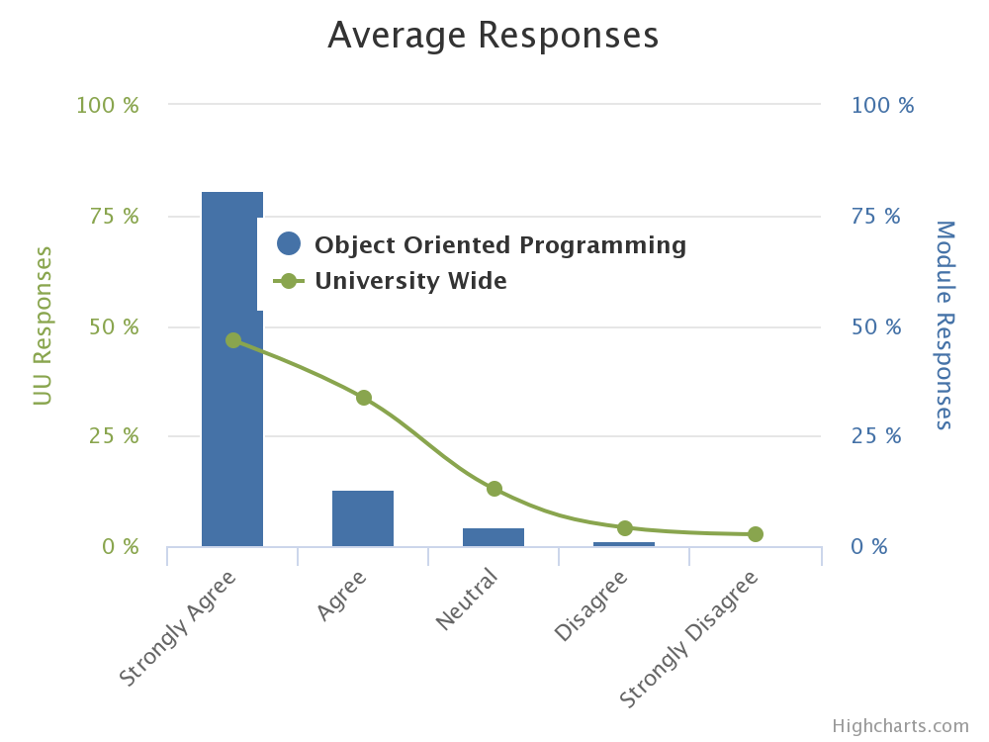
Figure 1: Average student responses from module feedback
References
Armellini, A. (2018). The large lecture (theatre) is dead… JISC. Available at: [https://www.jisc.ac.uk/news/the-large-lecture-theatre-is-dead-11-jan-2018]
Bergman, J. and Sams, A. (2014). Flipped Learning: Gateway to Student Engagement. International Society for Technology in Education.
Delozier, S. and Rhodes, M. (2016). Flipped classrooms: a review of key ideas and recommendations for practice, Education Psychology Review, vol. 29, pp1-11.
Flipped Learning Network (2018). What is flipped learning? The four pillars of F-L-I-P. Available at: [http://www.flippedlearning.org/definition]
GitHub. (2019) How GitHub Classroom and Travis CI improved Students’ grades. GitHub corporate blog. Available at: [https://github.blog/2019-02-12-how-github-classroom-and-travis-ci-improved-students-grades/]
Jonsson, H. (2015). Using flipped classroom, peer discussion and just-in-time teaching to increase learning in a programming course, Proceedings of the IEEE Frontiers in Education (FIE). IEEE. Available at: URL [https://ieeexplore.ieee.org/stamp/stamp.jsp?arnumber=7344221]
Karabulut-Ilgu, A. Jaramillo Cherrez, N. and Jahren, C. (2017). A systematic review of research on the flipped learning method in engineering education. British Journal of Educational Technology, Available at: [https://doi.org/10.1111/ bjet.12548]
Lou, H. Yang, T. Xue, J. and Zuo, M. (2018). Impact of student agency on learning performance and learning experience in a flipped classroom. British Journal of Educational Technology. Available at: [https://doi.org/10.1111/bjet.12604]
Montgomery, A. Mousavi, A. Carbonaro, M. Hayward, D. and Dunn, W. (2017). Using learning analytics to explore self-regulated learning in flipped blended learning music teaching education. British Journal of Education Technology. Available at: [https://doi.org/10.1111/bjet.12590]
Rosiene, C. and Rosiene, J. (2015). Flipping a programming course: The good, the bad, and the ugly, Proceedings of IEEE Frontiers in Education, IEEE. Available at: URL [https://ieeexplore.ieee.org/document/7344151]
ICERI paper: https://library.iated.org/view/WILSON2018LES
ADDL blog: https://addl.ulster.ac.uk/digitalfutures/view/panopto-ulsters-new-educational-video-platform

