Case Study
Title: vLog for Professional Practice (vPP)

Summary: Video logging (vLog) was used as a mechanism for documenting student activities on work-based learning placements. Using vLog as the basis for assessment in this context has several advantages over other methods.
- Creation of engaging user-generated evidence of placement activities.
- Maintain a sense of community through a group activity during placement.
- Raising awareness of placement and reducing barriers to participation.
- Digital footprints for monitoring engagement.
- Increasing recruitment to DPP, improving DHLE statistics and employability.

What was done:
Please give a brief description of the case study including the themes and priorities within five& fifty it relates to.
Explain why you feel this is an example of novel, enhancing, or innovative practice.

The last two GES DPP cohorts completed an assessed vLog. This activity was piloted using Vimeo without technical support and there was GDPR concerns about content being held by a third party.

The genesis of this work came from a helpdesk call which coincided with the implementation of Panopto. A commitment was established to collaborate during academic year 2018/19. Integration of the assessment within Blackboard provided the perfect opportunity to maintain academic value of the assessment, streamline student experience, avoid GDPR concerns and pilot Panopto on an applied student learning experience.

This cross-departmental collaboration demonstrates the core values of Five and Fifty; Integrity, Spirit, Living Knowledge, Unity, Openness and Fresh Thinking. This novel reflective assessment is aligned to Five and Fifty through;

- Civic Contribution demonstrating Ulster’s civic contribution through the network of placement opportunities.
- Academic Excellence – students develop new skills and knowledge enhancing the broader student experience of placement.
- Global Vision – students learn from peers about global opportunities inspiring students to seek international opportunities.
- Operational Excellence – challenging conventional placement assessment through more effective and sustainable methods.

Motivation and aims:
A brief outline of the reasons behind the practice described - its purpose and benefits. What change was it intended to make or problem was it designed to solve? What professional knowledge did you draw from to underpin your rationale?

Experiential and reflective vLogs are a novel way to test reflection and learning outcomes. The principle reasons, purpose and benefits are:
- inclusive and alternative assessment design allowing students to engage in an ongoing reflective process
- developing a shareable collection of student generated video assets to inspire and learn as a peer group

vLogs challenge the reflective process that may not always happen as a sequenced activity. Inspired by Ulster’s Integrated Curriculum Design Framework, we applied the principle to crowdsource the student’s placement experience. We asked the question of the employer and asked the student to describe what they need to Know, Do and Be. In terms of professional knowledge our work was informed by the Jisc Digital Tracker and Digital Capabilities Framework.

Implementation:
An outline of how you carried out the initiative, the approaches you adopted. What professional knowledge did you draw from to underpin your approach?

We used agile project management approaches to collaborate adapting our plan during implementation. There was a collective commitment to learn from each other and the students, producing ad-hoc support materials as we developed knowledge and understanding. We drew on Jisc resources such as https://www.jisc.ac.uk/guides/using-digital-media-in-new-learning-models/legal-considerations-for-video to consider legal and ethical issues.

Successes and lessons learnt:
Reflect on what worked well, any particular challenges faced and how these were addressed. Comment on the approach taken to evaluation and understanding the impact and effectiveness of the practice described. What did students think about your approach? Include evidence to support your understanding of its effectiveness.
Please also say if you are planning any changes or further developments.

Reduced barriers to entry for student generated video. Despite the myth of the digital native, this cohort demonstrated ability to create high quality video with a coherent narrative, achieved with minimal production instruction. With student approval, resources can be shared publicly to highlight the placements undertaken at Ulster. Placement videos from across Ulster could be published to an open resource inspiring students and placement providers.

The week 6 playlist generated 510 hits, and week 12 returned 148 hits from a cohort of 28 students. vLogs were shared with Year 1 & 2 students through Blackboard and access statistics are being similarly monitored. Additionally, the vLog cohort were surveyed. For 100% of the respondents, this was their first experience generating vLogs (n=11). 72% thought that the availability of vLogs would have helped the decision making about undertaking placement. 82% said they would feel more confident about video assessment. 100% of students were unconcerned about their online security and public availability of their content through this assessment.

We will continue to monitor interaction with the material, and the resulting uptake for DPP. We will ask new students whether this resource influenced their decision to participate. We will continue to develop the support material to help students create video content. We plan to create a generic guide for multidisciplinary vLogs. We will explore co-creation with students in the School of Media, Film and Journalism.

Transferability:
Is this practice transferable? Have you shared your experiences with colleagues? What would your advice be to others thinking of adopting your approach? Do you have any evidence of colleagues adopting your approach?

This practice is transferrable and applicable to different contexts. Within GES, there is scope to extend to DIAS and other experiential assessment addressing a range of learning outcomes. The practice was disseminated at a Faculty L&T Event where Chris presented - Front and centre: embedding employability in the GES curriculum. CHERP workshop work based learning and through the Faculty Sub-Committee for Employability’s Task and Finish Group for Work-Based Learning.

This initiative has caused a ripple of change and is being shared as best practice. Conversations have inspired an evaluation of the placement module in HTM within the Ulster Business School. Anecdotally, where colleagues have been exposed to the content generated, they have expressed significant interest in adopting this approach.

Further information:
e.g. links to website or publications, materials used, presentation slides, screen shots, testimonials;
a couple of quotes from students or staff illustrating the case study would be particularly useful

Professor Adrian Moore, Head of School GES, similarly commented on the project “This exciting and innovative work is helping to promote work-based learning opportunities for all of our students by giving them access to information about the placement experience from a student’s perspective, and allowing them to see first-hand the kind of experiences that work placement can offer. This work is an integral to our School’s initiative to increase participation and promote placement, which can enhance employability as demonstrated by DLHE statistics and NSS results. This is a showcase exemplar of our staff engaging with novel and efficient pedagogical approaches for course development with ODL”.

Professor Brian Murphy, Professor of Digital Learning commented on the work “This collaboration is a compelling case study that demonstrates the value of video for reflection and peer learning. The shareable assets created by Ulster’s diverse student body highlight the significant civic impact of Ulster students on the region through placement. This is a transferable methodology that will influence change in placement activity across Ulster and potentially beyond.”
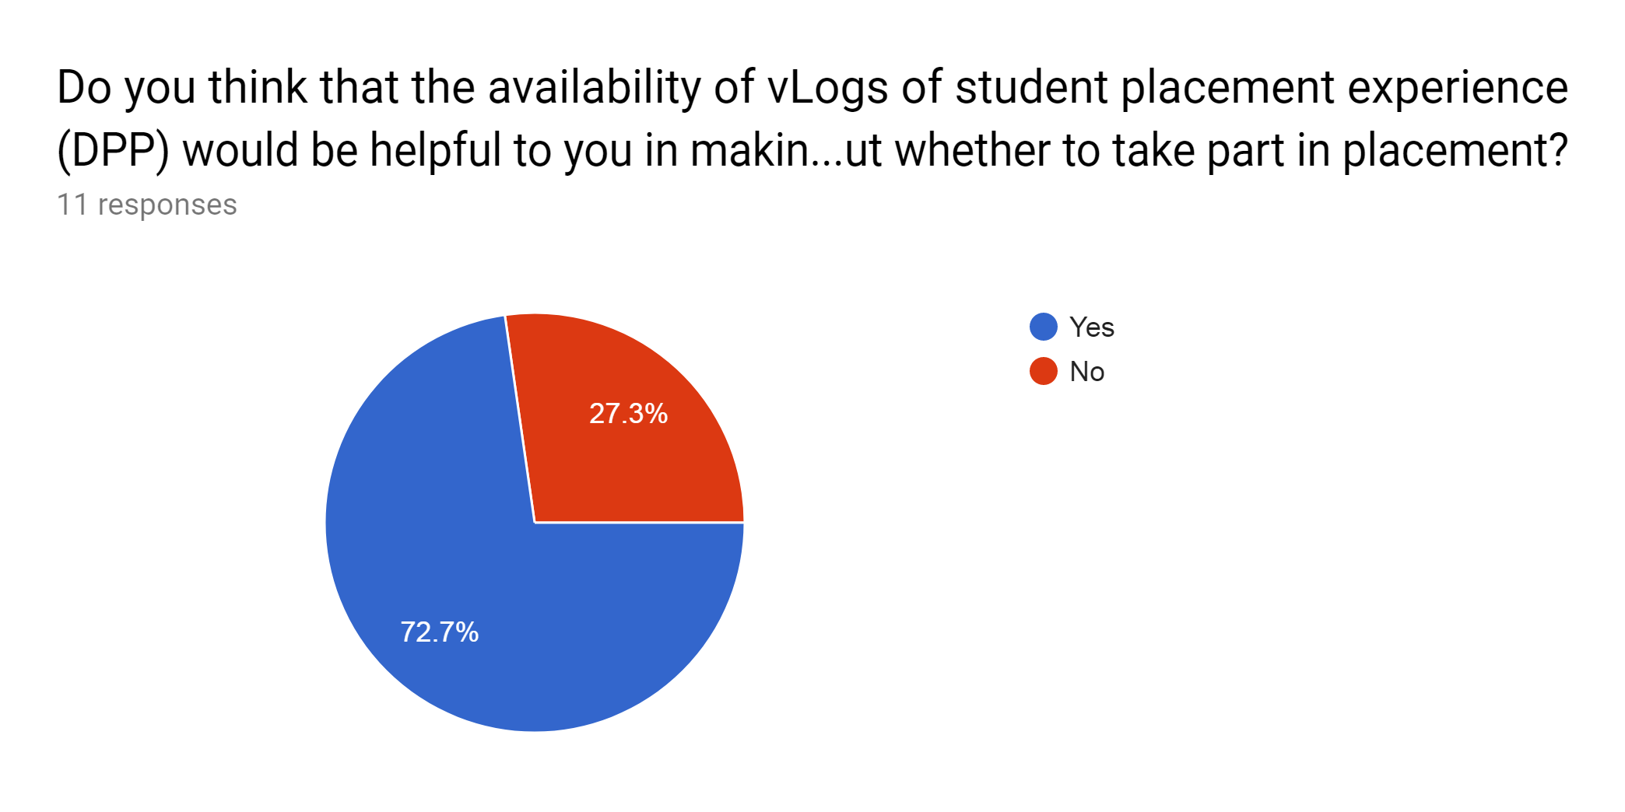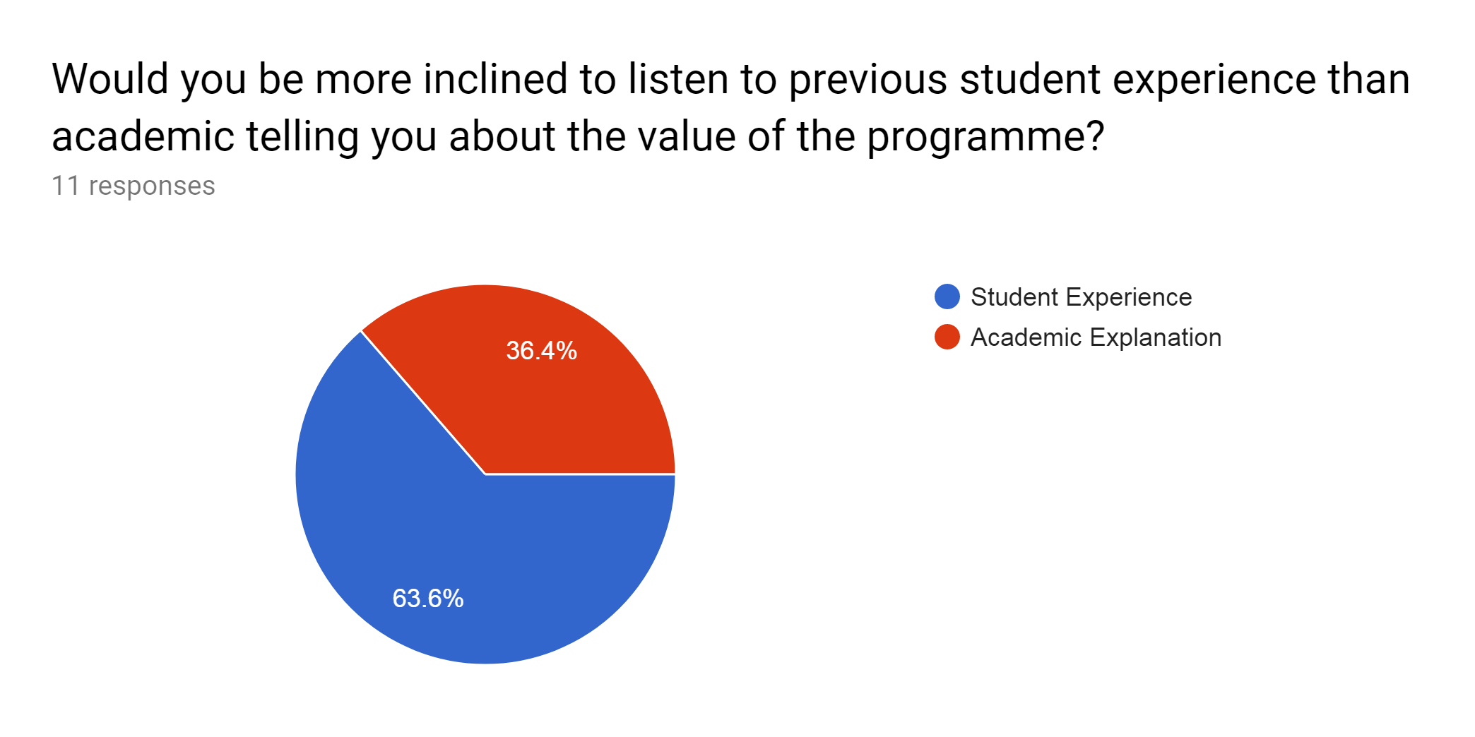
Figure 1. a) Sample of student feedback on the use of vLog as a placement support mechanism

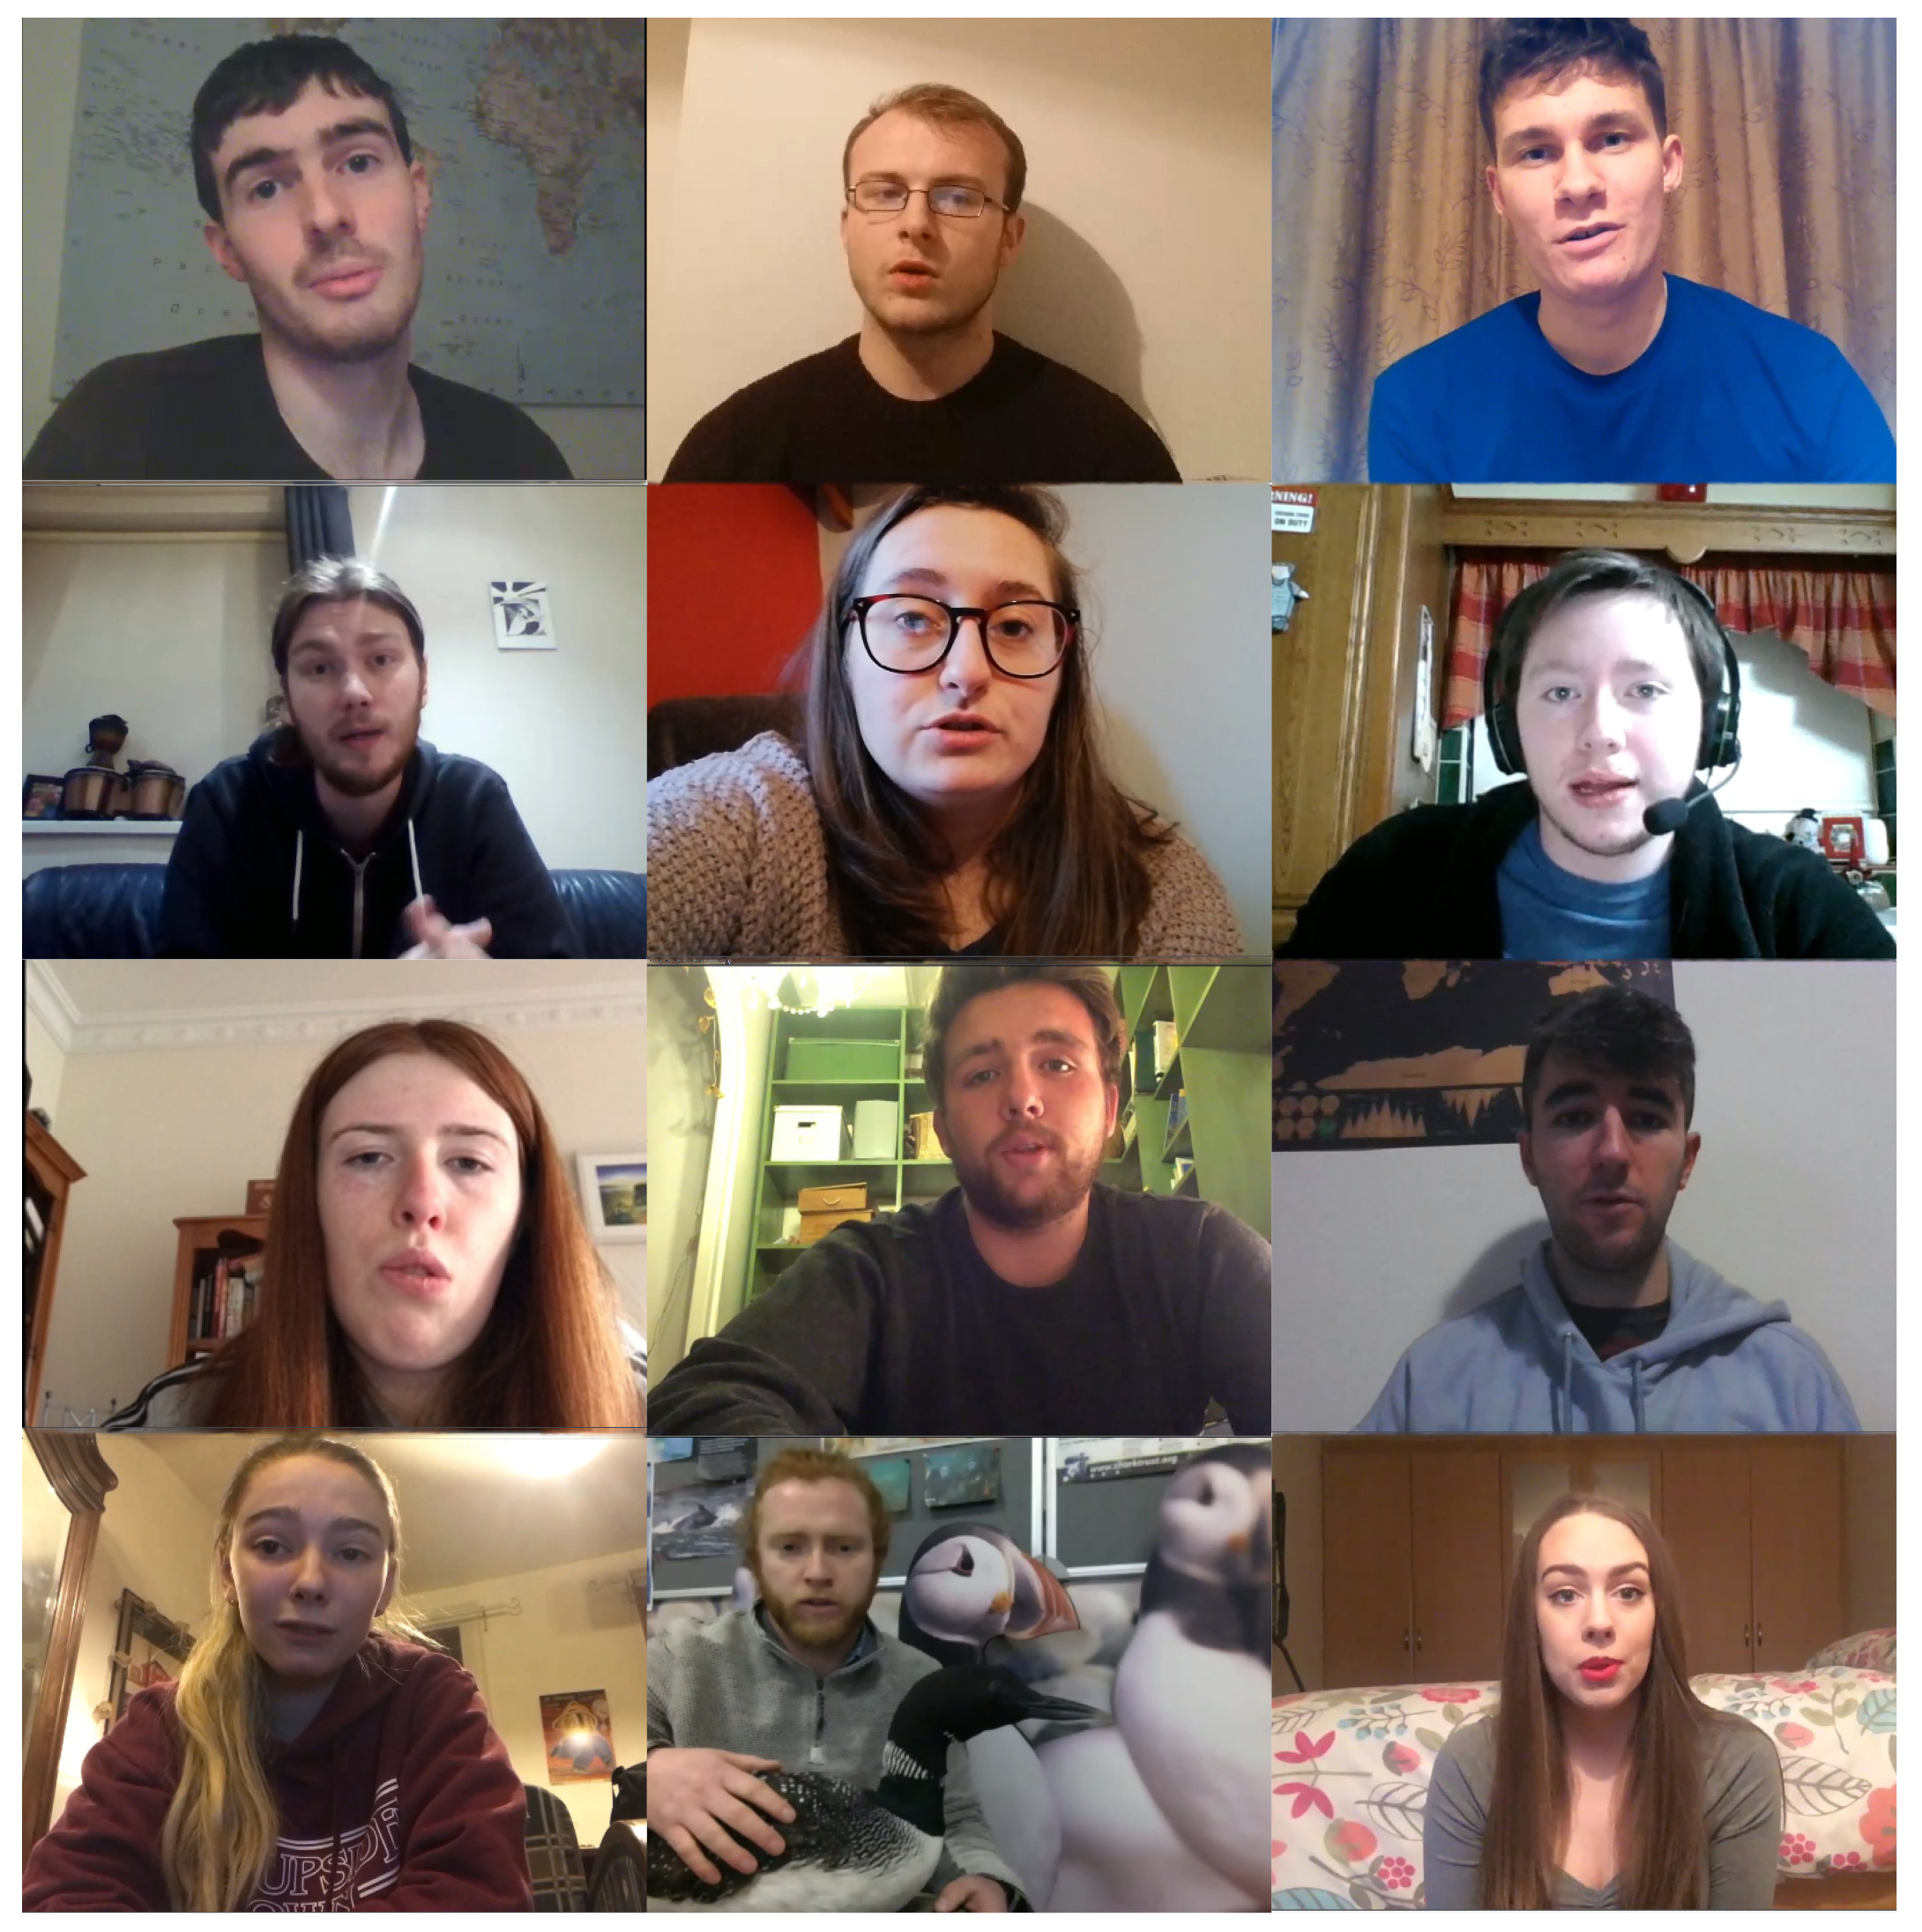
Figure 2: Selection of screen captures from GES DPP Student vLogs for module EGM300 2018/19.

