ULSTER UNIVERSITY Paper No CPF/19/15

COLLABORATIVE PARTNERSHIPS FORUM Agenda Item 13
2 October 2019

STAFF DEVELOPMENT

To consider a draft programme for the annual staff development conference at CAFRE on Friday 11 October 2019.

ACTION

For consideration.

CPF/19/15
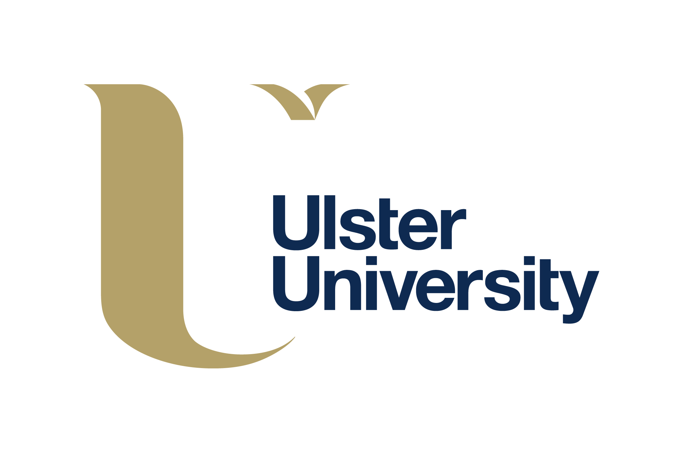
16TH ANNUAL CONFERENCE FOR HE STAFF AT PARTNER INSTITUTIONS
‘Delivering Quality in the New Era’

FRIDAY 11 OCTOBER 2019
THE CONFERENCE HALL, COLLEGE OF AGRICULTURE, FOOD AND RURAL ENTERPRISE
GREENMOUNT CAMPUS, ANTRIM

PROGRAMME
09: 30 - 10:00 am | Tea/Coffee/Scones on arrival
10:00 am 10:10 am | Welcome and Opening Remarks | Ms Carol Reid, Chair of Collaborative Partnerships Forum, Ulster University
10:10 am – 10:45 am |  | Professor Paul Bartholomew, Deputy-Vice-Chancellor (Academic), Ulster University
10:45 am – 11:30 am | QAA Quality Code | Mrs Caroline Turnbull  (Nations and Europe Team), QAA
11:30 am –11:45 pm | Tea/Coffee
11:45 pm - 12:15 pm | QAA Quality Codes Breakout Groups | Mrs Caroline Turnbull
12:15 pm – 12:30 pm | Question and Answer Session | Mrs C Turnbull & Ms C Reid
12:45 pm – 1:00pm | BMet Hospitality Hub
 | Hub (Science)
1:15 pm – 1:30 pm | Question and Answer Session | Ms C Reid
1:30 pm | Close and Lunch

