Instruction on Completion

Background | - As part of the University Health, Safety and Wellbeing (HSW) management process this self-audit checklist should be completed to assess HSW compliance, acknowledge good practice and identify actions required which will form the annual forward action plan for the year.  - It is recognised that structures for management of HSW within the University may vary so there is discretion for leadership/management teams to agree how this checklist is best completed to meet their specific needs.
Self-audit Annual Checklist & annual forward action plan | - This HSW self-audit checklist (Appendix 1) has been developed to address the need for active monitoring by Managers (Deputy Deans/ Directors, Heads of Department / School / Research Institute Directors)  - The “Action to Maintain or Improve Status” should form basis of the annual forward action plan (Appendix 2)  - When completed, this checklist and action plan will meet the minimum requirement for an Annual Report and associated annual forward action plan for review Statutory Committees (e.g. Campus Health and Safety committees and Faculty Health and Safety Committees) as well as Portfolio leadership HSW Committees and Working groups.
Action Required | - Managers should complete the checklist and submit to portfolio leadership team along with annual forward action plan no later than 30th September.  - Portfolio leadership teams may wish to complete one collated return with associated annual forward action plan for their portfolio.  - It is recommended the completed checklist is submitted with the annual forward action plan for review at the first meeting of the appropriate HSW Statutory Committees, or the HSW Portfolio Leadership Team meeting/ committee in that Academic Year.
Relevant Policy/procedures  And guidance | Policy and procedures relevant to the questions below can be found at  https://www.ulster.ac.uk/peopleandculture/health-and-safety  USHA Health and safety leadership and management standard

 | Instruction on completion
Requirement | Complete each column for the question asked.
Status  Compliant / Non-compliant / N/A | Please insert one of the following:  - Compliant – if the requirement is met and you can provide suitable evidence.  - Partially Compliant – if the requirement has been partially met although some work still required to become fully compliant  - Non-compliant – if you have not met this requirement  - N/A - If a requirement is not applicable then please input N/A and provide the reasoning under the ‘Evidence’ column.
Evidence | Please provide evidence to support the ‘Status’ column, examples:  Compliant: Provide evidence to demonstrate compliance e.g. all staff have completed manual handling training  Partially compliant: e.g. xx have completed manual handling training but xx still to be trained  Non-Compliant: Requirement to provide manual handling training has been identified following risk assessment of new work activities and is due to be completed.  N/A: Manual Handling training is not required
Action to Maintain or Improve | Actions in this column will form the basis of an annual forward action plan for the year. Please insert action to be undertaken, e.g.  Maintain  - Continue to assess and control risks through completion and reviewing of risk assessments.  - Staff whose manual handling training expires in coming year to have it scheduled  Improve  - Remaining xx staff to complete Display Screen Equipment training and DSE checklist to complete it.  - Continue to provide three monthly HSW toolbox talk to team.
Owner | - Name of person responsible for taking action forward to conclusion
Target Date | - Date action to be completed by.
Key | The checklist at Appendix 1 is colour coded to reflect the relevant stage of Health and safety PLAN DO CHECK ACT cycle.  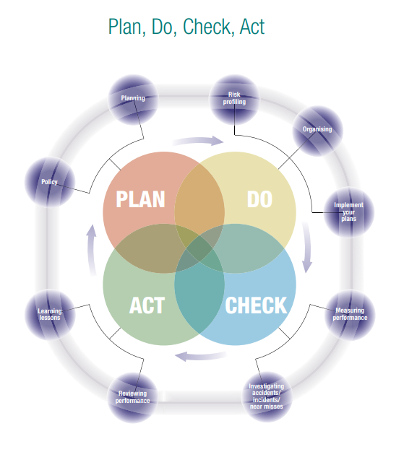

Appendix 1
Question | Requirement | Status  (Compliant / Partially Compliant/ Non-Compliant / N/A) | Evidence to Support Status | Action to Maintain or Improve Status (This should for basis of annual forward action plan) | Owner | Target Date
1 | A HSW policy statement is in place and has been communicated  Staff. (This may be at Dept faculty or portfolio level)
2 | Staff have clear roles and responsibility for HSW.
 | HSW is included in risk planning and management
3. | Documented risk Assessments and controls measures are in place for significant risks.  (Annual review recommended)
4. | a/Safe Systems of Work/ Operating Procedures in place, up to date and shared with relevant staff/students.  (Annual review recommended)
5. | a/Electrical appliances with a plug are included in schedule of portable appliance testing. (PAT)
 | b/Hazardous substances have documented risk assessments and appropriate controls in place.
 | c/Assessment of risk from stress completed and managed
 | d/Manual Handling related risks are suitably assessed and controlled
 | e/DSE Awareness training and individual self-assessments completed and risks appropriately managed
 | f/Exposure to Noise/ Vibration assessed and controls in place and monitored.
 | g/Contractors carrying out work with significant risks are competent and working safely
 | h/Work equipment/tools is appropriate for use, maintained inspected and used correctly
 | i/Working at Height is suitable assessed and controlled. Where it can’t’ be eliminated – training is provided to users, WAH equipment is right for the job and subject to checks and inspections.
 | j/Radiation (Ionising & Non-Ionising) risks are suitably assessed and controlled
 | k/Driving for Work has been assessed and suitably controlled.
 | l/Events are planned and assessed for safety and proportionate controls in place.
6. | The following have been assessed with practical measures in place and competent persons appointed where appropriate:
 | a\ Fire safety & Fire Marshals
 | b\ Provision for first aid is in place and access to First Aiders.
 | c\Health and Safety Co-ordinators
 | d/ Use of display screen equipment (DSE) Local DSE assessors
 | e\ Wellbeing Champion
 | f\Mental Health First Aider
7. | Staff have completed H&S training relevant to their duties. E.g. risk assessors have risk assessment training.  Training matrix includes relevant HSW training.
8. | Appropriate health & safety information is communicated to staff/students/others on a regular basis.
9. | Statutory inspection and examination of equipment schedule in place where required for following:
 | a\Local Exhaust Ventilation (LEV) Systems
 | b\Pressure Systems
 | c/Lifting Equipment and Lifting Accessories (under LOLER)?
10. | Staff have completed mandatory DSE Awareness e-learning
11. | Staff have completed mandatory Fire Safety e-learning
12. | Actions from last HSW checklist completed.
13. | Fire safety checklists have been completed (6 monthly) in previous academic year and any issues resolved.
14. | HSW internal audit actions been completed, where applicable, for previous academic year.
15. | Reported incidents (Injuries and near misses) are investigated per current procedure and appropriate action taken.
16. | Incidents have been reviewed to identify any trends/lessons learned and actions taken where required
17. | A process is in place to review HSW performance plans risk assessments, safe systems of work as appropriate.

Additional Comments:
Head of Department / School / RID
Print Name: ......................................................... Sign: .......................................................... Date: ........................................

Annual Forward Action Plan Appendix 2
Question  ref | Action needed to maintain/improve | Action by | Priority H/M/L | Target Date | Complete  Y/N

Head of Department / School / RID
Print Name: ......................................................... Sign: .......................................................... Date: ........................................

