Full paper title
Ali Nadjai, Jean-Marc Franssen, Faris Ali, Naveed Alam, Olivier Vassart

ABSTRACT
The length of the abstract should be no more than 15 lines. Authors may add a few keywords; however, the addition of the keywords is optional.
Keywords: Structures, finite element modelling, compartment fires, fire tests

Introduction
The papers should be prepared using the guidelines mentioned herein and using this template. It is preferable to submit the papers in MS Word DOC format in high quality print. PDF files may also be accepted if they follow the guidelines mentioned herein. The submitted PDF files should not have page numbers and should not be a secured document.

General

Paper, authors and affiliation
This format has been adjusted and modified as per the requirements of the conference and it is recommended to use this template for paper submission. For title of the paper, 14pt Times New Roman, bold, capital letters and centre adjusted are used. Names of the authors should be listed in full with their surname following the given and middle names. The affiliation of authors with their emails should be given in the footnote. Please use this template for convenience.

Paper size, margins and numbering
The use of page size A4 is recommended. The margins are set at; Top: 20 mm; Bottom: 20 mm; Inside: 25 mm; Outside: 15 mm. All text should be typed within the margins. Reference to the tables in the text should be made in in italic. For example, Table 1 summarizes the margins applied.
It is recommended not to insert page numbers.

Sections
The paper starts with the abstract followed by the numbered main sections/chapters. The list of the numbered references should be added at the end of the manuscript using the same template format. Addition of the acknowledgments is optional and should not be numbered.

Paper length and language
All submitted papers should be limited to 8 pages of size A4. Papers comprising of 6 pages will also be accepted.
Language of the paper shall be English, United Kingdom. All papers should be proofread before final submission.

Submission deadline
The deadline for the paper submission is 20th March 2018 via conference server.
It should be kept in mind that the acceptance of the abstract is not the automatic acceptance of your paper. All the extended papers will be peer reviewed, and thus the final decision for paper acceptance will be made based on this final paper review, after the final paper submission.
The file name must contain the ID Number, corresponding to the accepted abstract.

Section headings and text style

Heading 1
Format of section headings: bold capitals Times New Roman 12 pt. Line spacing before and after a heading is 18 pt and 6 pt, respectively. Please use the preset style Heading 1. Use consecutive numbering of the sections; the preset style comes with automatic numbering. Acknowledgments and References are not required to number (you may use abstract acknowledgment styles from this template).

Heading 2
Secondary headings are typed in initial capitals. Please limit the depth of headings to major and secondary headings.

Normal text style and list
The normal text is typed in Times New Roman 12 pt, justified with single line spacing.
For numbered or bulleted list please use the provided style templates
- List numbered
- List bullet.

Figures, tables and equations

Tables
Tables prepared in basic word format are preferred. Tables must be referred in the text in the format as Table 1. The smallest font size in the table shall not be smaller than 10 pt.
Table 1. Recommended margins in mm
top | bottom | inside | outside
20 | 15 | 25 | 15

Equations
Use the equation editor of Word with the standard settings (12pt italic Times New Roman). Equations shall be numbered. An example is given in Eq. (1).
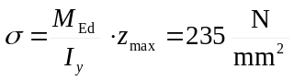 (1)
where M_{Ed} is the design bending moment,
⬧ is the acting axial stress, etc.

Figures, diagrams, illustrations
Figures, diagrams, illustrations should have a resolution of 600 dpi. When preparing figures, keep in mind that the proceedings will be printed in black&white (i.e. greyscale) and in the B5 format (78% of A4). Colour printing will not be provided. Reference to the figures shall be given in the text. Two-column figure arrangement as shown in Fig. 1 is allowed: use table without borders. The smallest font size in the figures shall not be smaller than 10 pt.
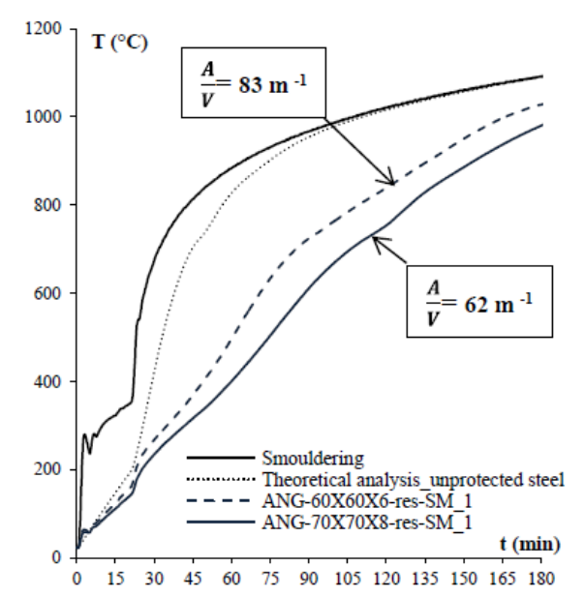a) | 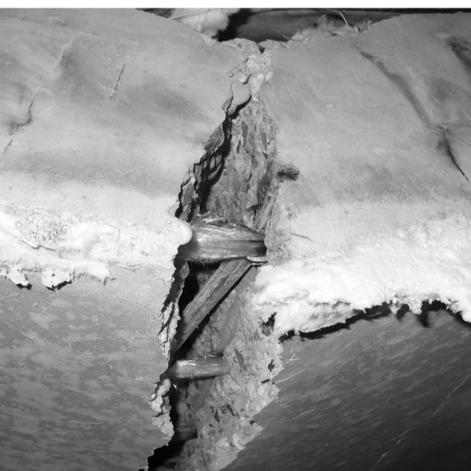 b)
Fig. 1. a) Drawing; b) Greyscale photograph

Preset formatS
All settings are already adjusted in the Formats listed below. Use these Formats to get a consistent layout of the conference proceeding.
- Paper Title
- Author Names
- Author Affiliations
- Heading 1
- Heading 2
- Heading 3
- Normal text
- List bullet
- List numbered
- Table
- Figure
- Formula
- Table Grid
- Abstract, acknowledge, references

CONCLUSIONS
A conclusion section is mandatory. This can either be as bullet points or as a paragraph as preferred by the authors.
Acknowledgment
Acknowledgments are optional.
The references used should be numbered in the list as given below; these corresponding numbers should be provided in the manuscript as referencing. The proposed method for referencing in the manuscript is [1].
References
- Ali Nadjai, Colin Gareth Bailey, Olivier Vassart, Jean-Marc Franssen, Han Sang-Hoon (2011). Full-scale fire test on a composite floor slab incorporating long span cellular steel beams. Structural Engineer 89(21). pp 18-25.
- Naveed Alam, Ali Nadjai, Faris Ali, Walid Nadjai (2018). Structural response of unprotected and protected slim floors in fire. Journal of Constructional Steel Research, 142. pp 44-54.
https://doi.org/10.1016/j.jcsr.2017.12.009
- Naveed Alam, Donetella de Silva, Ali Nadjai, Emidio Nigro (2017). FE modelling for response of slim floor systems in fire and effects of intumescent coating. 2nd International Fire Safety Symposium, Naples Italy, June 7–9, IFireSS, 2017. pp 735-742

Professor and Director of Fire Safety Engineering Research Technology Centre, Ulster University, Belfast, UK.. e-mail: a.nadjai@ulster.ac.uk
Professor. Department of Architecture, Geology, Environment & Constructions (ArGEnCo), University of Liège, Belgium. e-mail: jm.franssen@ulg.ac.be
Professor. Belfast School of Architecture and the Built Environment, , Ulster University, Belfast, UK. e-mail: f.ali@ulster.ac.uk
PhD Candidate. Belfast School of Architecture and the Built Environment, , Ulster University, Belfast, UK. e-mail: alam.n1@ulster.ac.uk
Head of ArcelorMittal Global R&D Long Carbon. Department of Research & Development, Luxembourg. e-mail: olivier.vassart@arcelormittal.com

