Our Collaborative Approach:

Whilst we had worked together prior to the work detailed below, we had not worked collaboratively in order to deliver such an interdependent aim. Our aim was to enhance student engagement and the overall learning experience through a more effective use of PowerPoint to support our lectures and encourage more active student learning. This required a consistent and coordinated approach across the modules delivered. The team comprised of five colleagues from the Department of Management and Leadership (now Department of Management, Leadership and Marketing). Three of the members undertook the role of delivering the course material, the fourth acting as an evaluator of the project and the fifth as a critical friend.

We met regularly to plan the delivery of the modules to ensure consistency around the use of PowerPoint, development of the Active Learning sheets (see below) and the language used. This collaborative effort was especially notable as the project was implemented across three different types of module (one skills based, one largely quantitative, one more qualitative in nature). The team had to collaborate to develop and test an approach that would work across these substantially different forms of module content. We each struggled in developing the materials in the early weeks and found the best way was to redesign our delivery materials for the initial weeks as a group rather than as individual module coordinators.

We held regular check-in meetings throughout the semester to support one another as challenges, ideas and opportunities emerged.

We involved the students in the initiative through two focus groups. The first was with students progressing into year 2 who reflected on their experience. The second involved those students who experienced the new approach at the end of their first semester. We also recruited a student partner who provided insight across the project. Students from the first focus group reported an expectation that PowerPoint would be used and that it provided a structure to the lecture, adding that it allowed them to re-join a lecture should they get lost or check a point they had missed (this directly led to the creation of Active Learning sheets). There was a consensus among the students that they didn’t want excessive text in the slides or a de facto textbook chapter, supporting our own intuition and reading. They cited the best lecturers’ slides to be concise; mentioning particularly one lecturer whose slides would “just be key words and then he would talk about them” or another who used the slides: “like a skeleton… and then embellished their own [content]”. This gave us the confidence to develop and implement our ideas.

The student partner for this project was Amy-Joy McConville, final year BSc (Hons) HRM student as we did not wish to use a student from within the pilot group. Amy-Joy inputted her experience across the four years of her degree and shared knowledge on both good and bad practice alike. This in turn allowed the development of materials to be taken from both staff and student perspectives on ‘what works’.

Case Study of the Team-Based Initiative
Title: Returning the Point to PowerPoint

Summary: This initiative involved the development and pilot of an alternative, more active and participative approach to the utilisation of PowerPoint within lectures. This involved the redesign of PowerPoint presentations within the lectures in accordance with evidence-based research supplemented by newly developed active learning worksheets.

What was done:

As part of Strategic Aims 1 and 2, Ulster University seeks to embed and develop active learning environments, involve students as partners and build upon new / emerging technologies. The rationale for this initiative was entrenched within Ulster University’s Learning and Teaching Strategy (2013/14 -2017/18), Five & Fifty and its demands for academic excellence and more broadly, the call by the HEA to enhance active learning environments and engage with students as partners rather than passive recipients of information (Healy et al. 2014, Curran and Millard, 2016).

The case study in question involved a pilot project that sought to rethink the use of PowerPoint and facilitate a more active and participative pedagogic approach (PowerPoint for Active Learning or PPAL).

Guidelines for the design and use of PowerPoint presentations were developed based on the literature e.g. Mayer’s (2001) multimedia learning and Active Learning Worksheets for each lecture were also created. These sheets included key learning questions ranging from the formation of key definitions and evaluation of certain concepts or theory, to solving problems or set calculations.

The redesign of the PowerPoint presentations served to enhance the student experience (consequently contributing to the achievement of the student experience objective as outlined within five& fifty) while the introduction of active learning worksheets demonstrated teaching excellence offering a novel approach to teaching and learning within our school.

Motivation and aims:

PowerPoint has been widely adopted in Higher Education (Craig and Amernic, 2006; Roehling and Trent-Brown, 2011) and expected by students (Marsh and Sink, 2009). However, more contemporary research has increasingly reported a decrease in student satisfaction with PowerPoint being used in lectures (Jordan and Papp, 2013), as the following tweets from students illustrate:

(taken from Schuman, 2014)

Research has found that either PowerPoint has “no measurable influence on course performance and minimal effect on grades” (Hill et al. 2012: 243) or that it is actually a detriment to student performance (Savoy et al., 2009). In addition, student engagement and the process of active learning are other areas of concern with the current use of PowerPoint potentially compromising engagement and encouraging a more passive approach to teaching and learning (Craig and Amernic, 2006). Against the backdrop of the National Student Survey, this trend is particularly concerning.

Our intention was not to suggest that PowerPoint in itself is the problem (Craig and Amernic, 2006) rather, as Jordan and Papp (2013) show, the problem lies in the way in which PowerPoint is used. As such, the change intended was to foster (or rejuvenate) active learning by rethinking our use of PowerPoint.

Implementation:

After a thorough literature review, focus groups with colleagues and with students, we developed the PowerPoint for Active Learning (PPaL) initiative.

The project involved 2 groups of BSc Management and Leadership Development students: a control group (outgoing year 1 students) and an experiment group (incoming year 1 students) who would be holistically emerged in this alternative approach making it their entire frame of reference.

Team members developed a design guide for their use of PowerPoint based on the literature (e.g. Mayer’s (2001) multimedia learning) that was followed in module delivery. This included: minimising the amount of text per slide; limiting bullet point lists; and increasing use of meaningful images or graphs. An illustration of the difference is presented in the ‘Further Information Section’).

Fig 1. Slides used with the ‘Control’ Group.

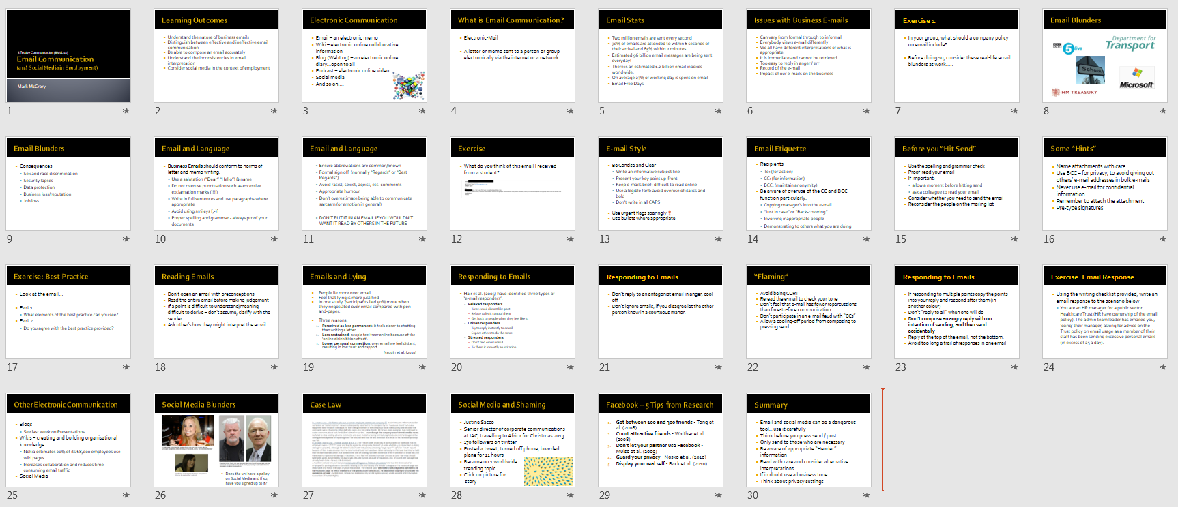

Fig 2. Slides used with the ‘Experiment’ Group for the same lecture but adhering to the new slide guidelines.

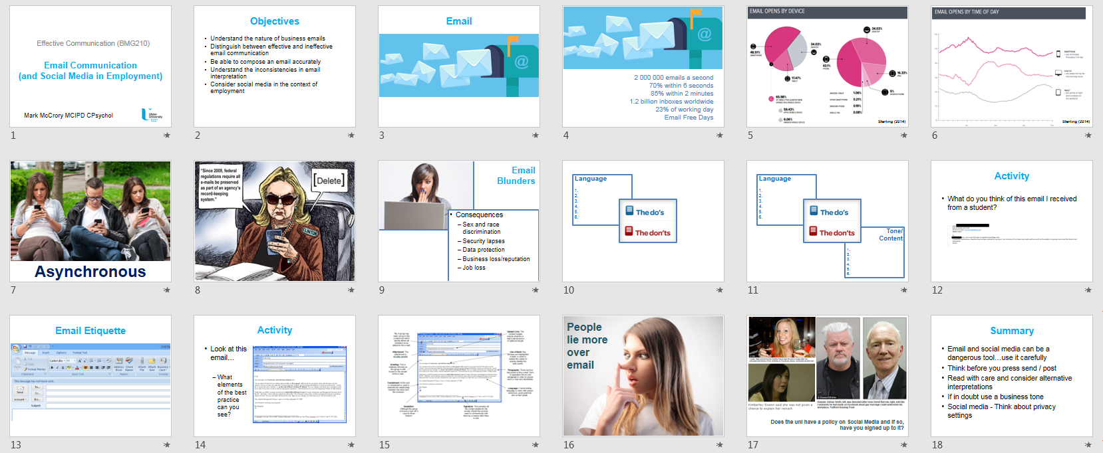

Active learning worksheets were also created in lieu of providing students with PowerPoint slides.

Fig 3. Example of an Active Learning Worksheet

The fourth member of the team led the evaluation of the approach, conducting a focus group with students and gathering reflections from each of the team members involved in delivery.

Successes and lessons learnt:

Qualitative Findings - Student Focus Group

Three key themes emerged from the focus group with the students from the experiment group.

Firstly, as expected, students discussed the importance of attendance to be able to complete their worksheets.

Secondly, there was a significant number of comments focused on positive engagement created through the redesigned slides which emphasised imagery and minimised text:
- “I like more creative things, I liked the pictures better so…put up a picture and talk round it”
- ”The slides were simplified but it was good…[the lecturer] engaged you with the way they would speak about the topic”

The students also reacted positively to the Active Learning Worksheets: “I liked them, to be honest I would prefer having them [worksheets] to the slide handouts”.

Lastly, students reported the redesigned slides and Active Learning Worksheets as significant aids in preparing for and undertaking assessment:
- “I think the way they did it too made it easier to remember because whenever you were revising it you could be like ‘that was the day they had this picture or that diagram’”
- “Each assignment you could go to the point on the worksheet and know what information you needed for it…it gave us a basis of what our plan was going to be for writing the assignment”

Qualitative Findings - Course Delivery Team Reflections

One of the most frequent comments made by the course team related to student engagement with all of those involved noting a marked improvement in the degree of engagement in class:
- “I noticed a tangible improvement in student engagement, it was the first time in a while where I really felt like the majority of the class were in the room and participating in the lecture and engaging with the content being addressed” (Lecturer 1).

Reflections indicated that the pilot project initiated a period of self-reflection among the course team with one lecturer noting how “lazy” PowerPoint had made them.

Despite the very positive reflections offered there were also some challenges identified and questions raised. Firstly, all of those within the course team referred to the time commitment required in developing the resources necessary for the new approach to PowerPoint i.e. developing Active Learning Worksheets, stripping back PowerPoint slides and replacing with suitable imagery, developing robust supporting notes for delivery.

Secondly, while the project was designed in a way that meant students did not have access to the slides used in class, in the wake of persistent requests for access to the slides from students, questions have been raised as to whether this was the correct approach.

Finally, it was agreed that the PowerPoint slides would in future be available as well as the Active Learning sheets.

Quantitative Findings – Performance

Table 1. Student performance within the Experiment and the Control Groups
 | Experiment Group | Control Group
Semester 1 Average Performance | 63.1% | 63.2%
Year 1 Average Performance | 61.4% | 59.9%

Disappointingly, no significant differences in performance were found between the Experiment and the Control groups. However, this is in keeping with the literature (e.g. Hill et al., 2012), that PowerPoint makes no discernable difference to student course performance. From a positive perspective though, lecturers can have confidence that stripping text out of their slides and being less dependent on PowerPoint should have no significant impact on student performance.

Fig 4. Attendance in Semesters 1 and 2 for the Experiment and Control Groups

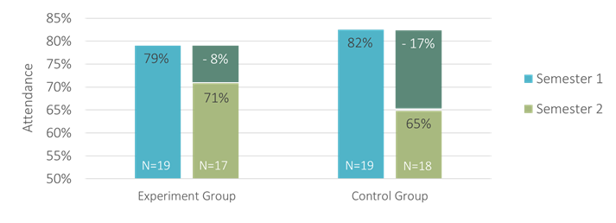
Attendance dropped by 8% from semester 1 to semester 2 with the Experiment Group, compared to a drop of 17% in attendance from semester 1 to semester 2 the previous year with the Control Group. The difference on attendance in semester 2 was statistically significant.

The lecturers, assessment, attendance monitoring and attendance meetings were all identical in semester 2 for the Experiment and Control Groups. The PPAL pilot was purposively not continued in semester 2 so the learning materials were also exactly the same. As such, it would seem then that a habit or culture of attendance was embedded in the Experiment group that wasn’t in the Control group the previous year.

Transferability:

The project was designed to explore PowerPoint and develop an alternative and more participative approach to its use in lectures. The alternative approach was adopted within three different module settings each with their own unique content including a more quantitative module. Despite such differences, the pilot approach proved beneficial suggesting that such an approach might be useful across a variety of different modules, courses and faculties. The premise and key principles identified through the project are relatively simplistic and open to cross faculty implementation, but we doubt they are common practice.

We have shared our experiences both internally and externally. Focusing on the topic of Active and Digital Learning the UUBS Annual Learning and Teaching Enhancement Event provided the ideal forum to share the findings and insights generated. Externally the research was presented at the CABS Learning, Teaching & Student Experience Conference. In both instances, the project and its findings were well received, generating positive feedback. A number of colleagues requested examples and the resources produced to assist in their implementation of the alternative approach proposed.

Our advice to others would be not to underestimate the work involved in taking an approach like this. PowerPoint slides comprising bulleted lists are so prevalent because they are quick to create and require little thought. The payback however should be a positive change in terms of attendance and student engagement. Lecturers can also be confident that student performance will not be impacted by removing copious text from their lecture materials. Interactions with colleagues indicate that some of the principles and lessons gleaned from the pilot have since been adopted and integrated as part of their respective modules.

Further information:

Focus groups with students supported the case study, the need to rethink the way in which PowerPoint was being used in practice and the effectiveness of the pilot approach employed, as the following quotations indicate:

“Pick a wall and look at it, after a while that’s just what [the lecture] feels like, stuff just did not go in, it was horrible.” (Control Group Student)

“[During the pilot] I felt engaged in class…for example [lecturer 1] asked the group questions…[lecturer 2] was good because he related it to a real life thing, made it kind of fun, drew pictures and diagrams, we even played hangman when trying and work out answers to questions…I also like pictures better so, for example, [lecturer 3] would just put up a picture of something and then talk round it and I found that engaging.” {Experiment Group Student]

Testimonials from staff also supported the case study and pilot approach:

“[Adopting the alternative approach] I noticed a tangible improvement in student engagement, it was the first time in a while where I really felt like the majority of the class were physically and mentally in the room.” [Lecturer 1.

