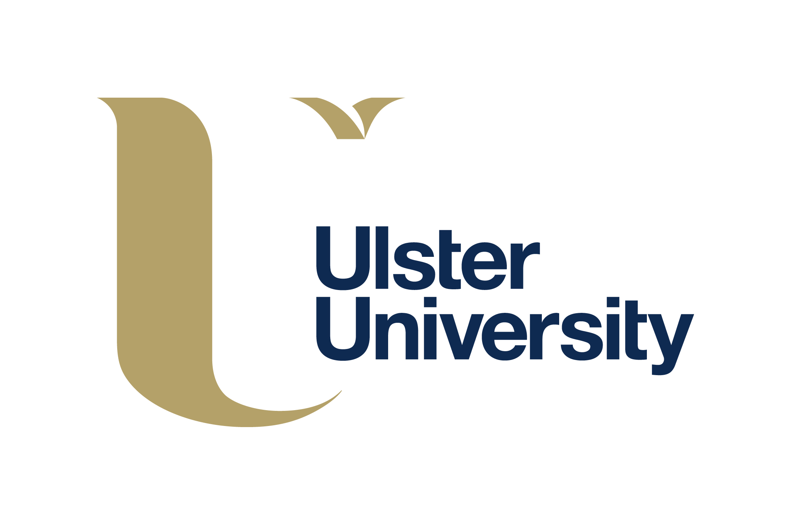

**ANNUAL STAFF CONFERENCE FOR HE STAFF AT PARTNER INSTITUTIONS**

***‘CURRICULUM DESIGN’***

**FRIDAY 20 OCTOBER 2017**

THE CONFERENCE HALL, COLLEGE OF AGRICULTURE, FOOD AND RURAL ENTERPRISE

GREENMOUNT CAMPUS, ANTRIM

## PROGRAMME

|  |  |  |
| --- | --- | --- |
| 09:30am – 10:00am | Tea/Coffee/Scones on arrival |  |
| 10:00am – 10:15am | Welcome and Opening Remarks | Mrs Maeve Paris, Chair of Collaborative Partnerships Forum, Ulster University |
| 10:10am – 11:30am | Approaches to Curriculum Design | Professor Paul Bartholomew, Pro-Vice-Chancellor (Education), Ulster University |
| 11:30am – 11:45am | Tea/Coffee/Biscuits |  |
| 11:45am – 11:55am | Outcomes from the Review of APEL Arrangements and Agreement on Benchmarks for Retention and Success | Subject Partnership Managers |
| 11:55am – 12:15pm | Improving Student Attendance and Retention – It’s a ‘SNAP’ | Mr Mark Poulter, Course Director, BSc Hons Physiotherapy, School of Health Sciences, Ulster University |
| 12:15pm – 12:40pm | Student Experience of Engagement with FE and HE | Mrs Susannah McCall, Subject Partnership Manager, Faculty of Social Sciences, Ulster University with Mr Elvin Cochrane and Ms Geraldine Hammond. |
| 12:40pm – 1:10pm | Elevated Learning through Industry Engagement at CAFRE | Dr Kate Semple and Mr Peter Simpson, College of Agriculture, Food and Rural Enterprise (CAFRE) |
| 1:10pm – 1:30pm | Enhancing Learner Experience: Widening Participation and Student Voice | Ms Jennifer Campbell and Ms Oonagh McGarrity, Belfast Metropolitan College |
| 1:30pm | Lunch |  |