General Emergency Evacuation Procedure (GEEP)

This Generic Emergency Evacuation Plan (GEEP) aims to give users of the building, particularly those with a disability or who may not be able to evacuate unaided, the information they need to evacuate safely.

Safely Exiting the building

Everyone should follow the simple steps outlined below to identify primary and secondary escape routes in the event of a fire alarm or other emergency.

Always locate your emergency escape route by identifying the nearest available stair core or final exit point from the building. This will be indicated by the green emergency exit signage shown below.

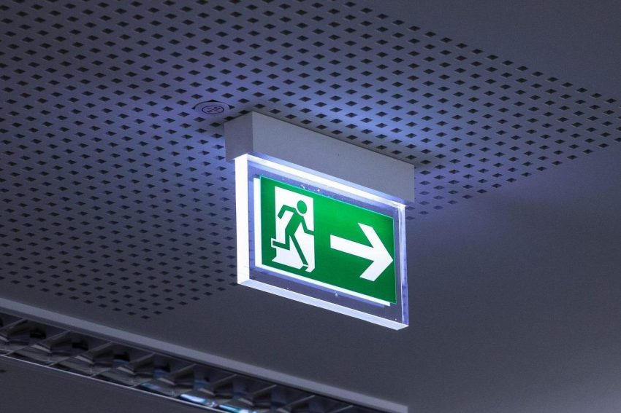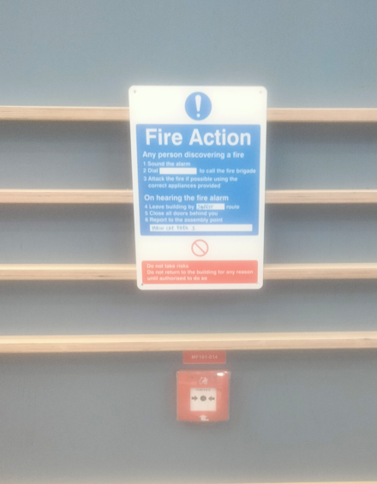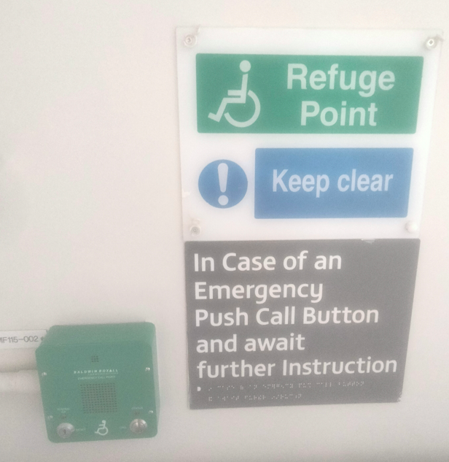

Following the green emergency exit sign will lead to a stair core (which are fire protected areas to allow safe orderly evacuation) or a final exit to outside if on Ground floor/ level 0.

Fire action notices are located prominently throughout the building and include the location of the nearest assembly point from that exit.

The secondary emergency escape route is an alternative exit route, should the primary route be inaccessible i.e blocked due to fire/smoke. Identify this route, by considering how to access the core or outside safely if the primary route is blocked. Remember the green emergency exit sign will take you to a relative place of safety (fire protected stair core) or place of safety outside.

If able, you should leave the building immediately by the nearest fire exit and report to the assigned assembly point for the building. If you are unable to evacuate the building unaided, please proceed to one of the safe refuge point.

Refuge points are located on every stair core on each floor. Anyone who needs assistance to evacuate safely is advised to go to this point and press the button on the Emergency Voice Communication System to speak with a member of the security team who are trained in use of accessible evacuation lift or chair as appropriate.

N.B In the event that the refuge systems become faulty or there is remedial work, use the below contacts to contact security for assistance.

Emergency contacts
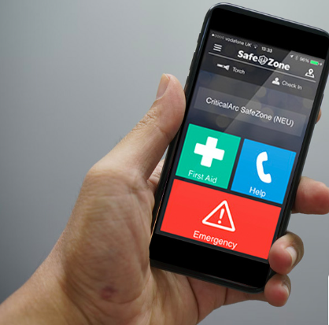

Assistance can be requested by: -
- using Safezone App
- Phone 02871 675262 (24/7)
- If using an internal phone dial ext. 22222

Assembly Points

The fire assembly points for the magee campus are listed below:

Magee Assembly Points​
​
- Main Car Park 1​
- Front of Library Building [Block MM]​
- Car Park 3 at Carrickmore House Building ML​
- Car Park 4 at Foyle Arts Centre​
- Car Park 6 at Block MH​
- Sports Pavilion Car Park at Duncreggan Student Village​
- Coppin House – Strand Road​

More information is available at https://www.ulster.ac.uk/wellbeing/disability/accessability/Personal-Emergency-Evacuation-Plans
For all campuses

Common areas

Block | Room | Primary | Secondary
MD | 008A Martha Magee’s | Exit second door on right go straight through double doors and exit out. Continue to fire assembly point. | Leave room through main door, turn left to enter main building foyer, and exit through the main entrance of the building. Continue to fire assembly point.
MD | 0048 Fitness Suite | Exit room by entrance returning into entrance foyer and exit by main entrance doors. Continue to fire assembly point. | Exit room by single exit door on left hand side Pass through staircase enclosure and exit via sliding door. Continue to fire assembly point.
MD | 102  Great Hall | Leave by main entrance door to hall. Refuge point is located beside the lift, press ‘call’ for campus security assistance | Contact campus security on 02871 675262 for assistance to exit by door on right hand wall (when looking toward the front). Note this door leads to a flat roof which is a place of relative safety but there are three small steps down beyond the door which may be negotiated with assistance from other people escaping. Leaving the flat roof will require trained assistance such as security.
MD | 108 Minor Hall | Leave by door on the left (facing screen), enter the room, directly ahead you will observe the refuge point. Contact security via refuge call point or 02871 675262 for assistance | Leave room by main entrance or single door at opposite end of room to main entrance. Wait outside room MD112. Contact campus security on 02871 675262 for assistance.
MG | 068  Main Sports Hall | Exit via lobby and out via main entrance. Continue to fire assembly point. | Exit via any of the exit doors in hall straight to open air. Continue to fire assembly point.
MG | SU The Bunker (MG 026A & MG 025) | Leave by main entrance to SU and turn left. Exit G block to open air. You may wait here and phone for assistance from security (02871 675262) or continue across to Block F, pass through block to open air at car park side. Continue to fire assembly point. | Exit to open air through doors to the side of the servery. Contact campus security on 02871 675262 for assistance.
MG | 005 SU | Leave by main entrance to SU and turn left. Exit G block to open air. You may wait here and phone for assistance from security (02871 675262) or continue across to Block F, pass through block to open air at car park side. Continue to fire assembly point. | Leave by double doors (MG026A then MG026B) and exit to open air. Contact campus security on 02871 675262 for assistance.
MG | 024 SU Games Room | Leave by door into staircase enclosure and turn left or right Exit G block to open air. You may wait here and phone for assistance from security (02871 675262) or continue across to Block F, pass through block to open air at car park side. Continue to fire assembly point. | Leave by door into The Room MG005. Leave by double doors on left (MG026A then MG026B) and exit to open air. Contact campus security on 02871 675262 for assistance.
MM | Library  Ground floor | Exit via main entrance. Continue to fire assembly point. | Leave area and proceed to staircase enclosure at the far end. Exit to open air and continue to fire assembly point.
MM | Library  Above ground | Leave area and continue to nearest staircase enclosure. Contact campus security via refuge call point or call 02871 675262 for assistance. Note: there is a protected staircase at each corner of this building above ground floor level. | Leave area and continue to nearest staircase enclosure. Contact campus security via refuge call point or call 02871 675262 for assistance. Note: there is a protected staircase at each corner of this building above ground floor level.
MM | 120  Cafe | Leave café via entrance door, turn left and enter staircase enclosure. Contact campus security via refuge point or call 02871 675262 for assistance. | Leave café by exit door to the right of the servery. Proceed along corridor past group study rooms and through door at end. Turn right and enter staircase enclosure. Contact campus security via refuge point or call 02871 675262 for assistance.
MM | 221 Computer Suite | Leave by either door or turning left or right enter nearest staircase enclosure. Contact campus security via refuge point or call 02871 675262 for assistance. | Leave by either door or turning left or right enter nearest staircase enclosure. Contact campus security via the refuge point or call 02871 675262 for assistance.

